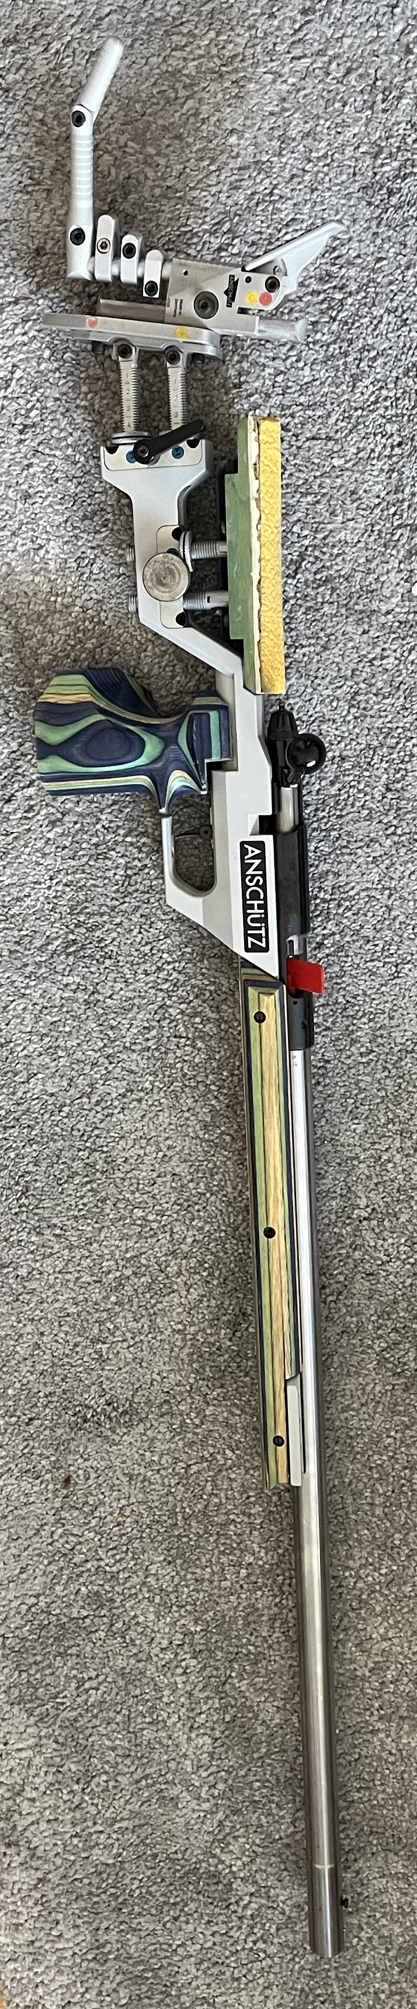
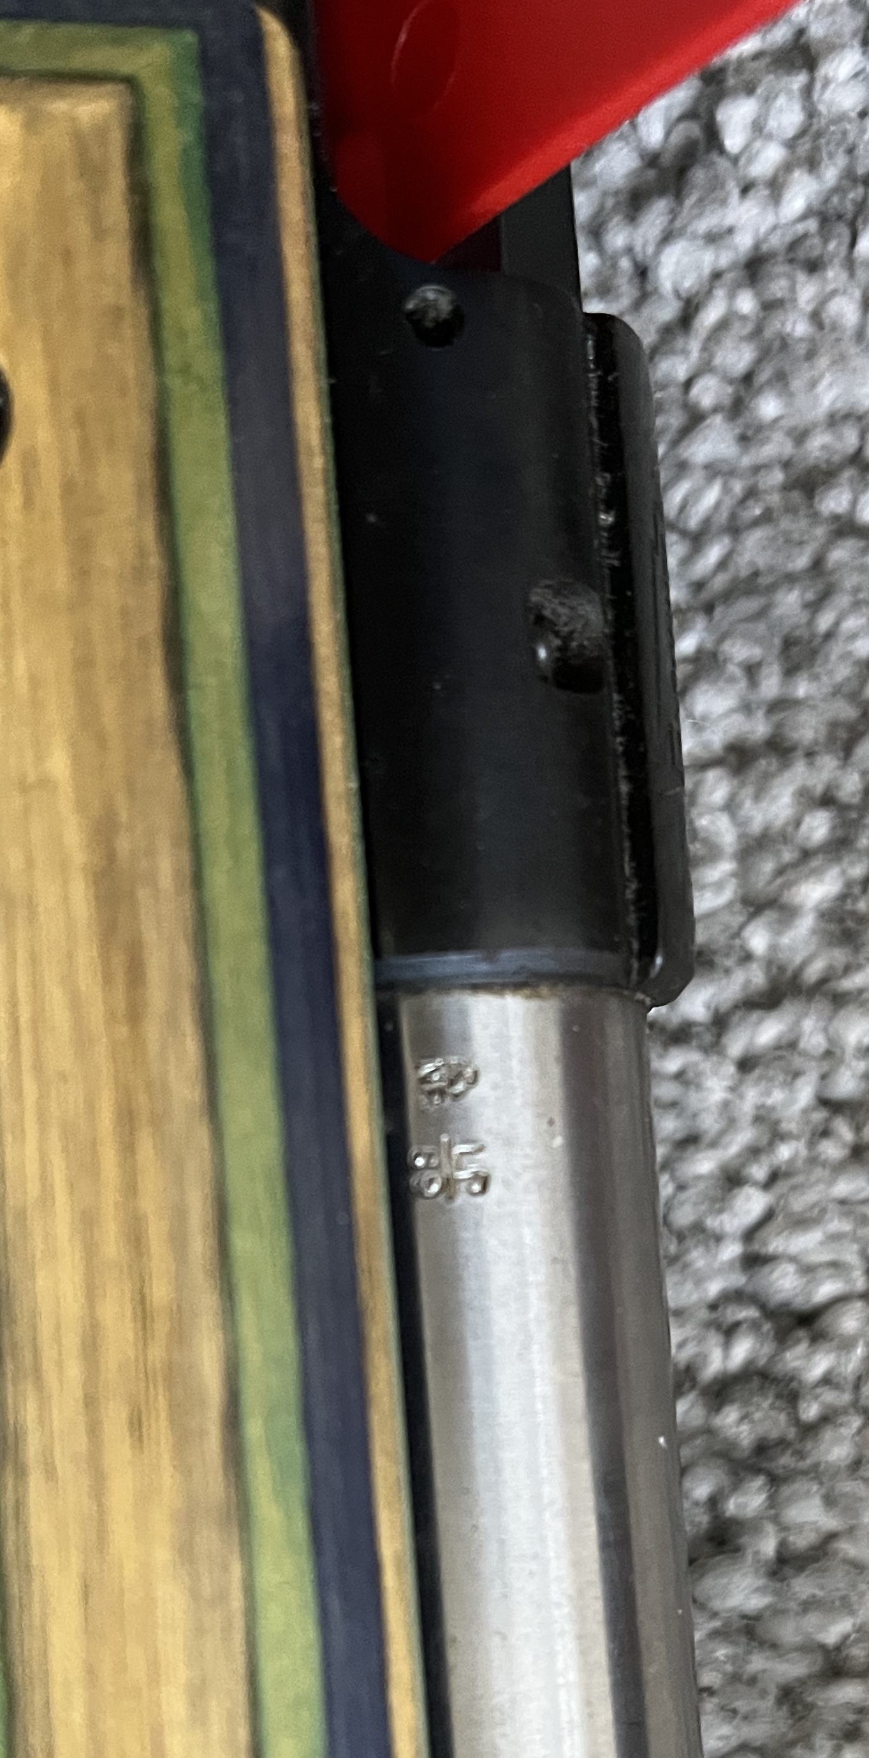 | 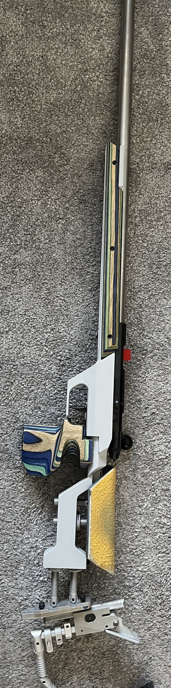
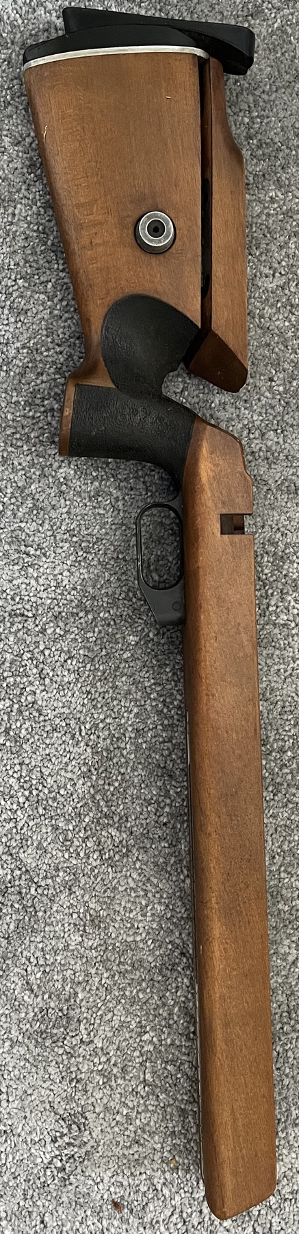 | 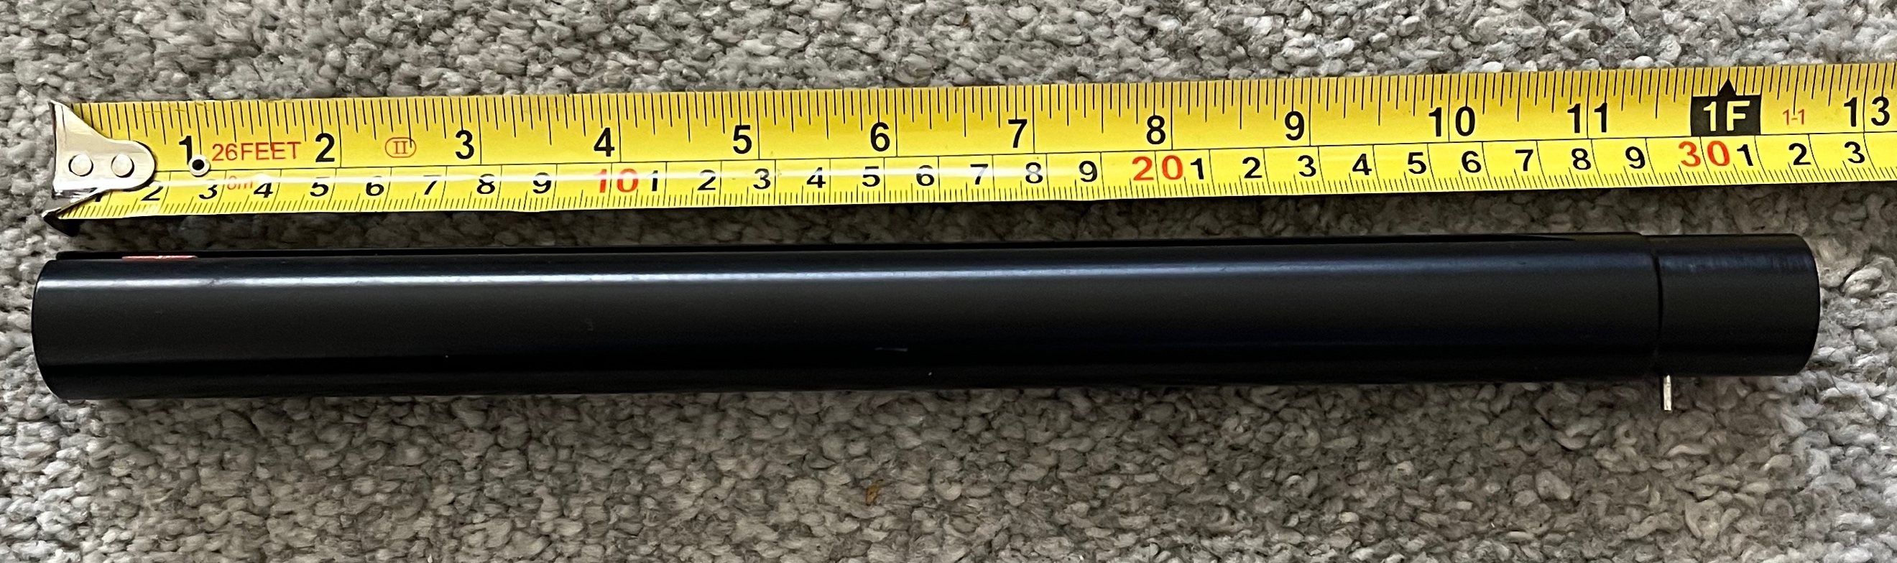
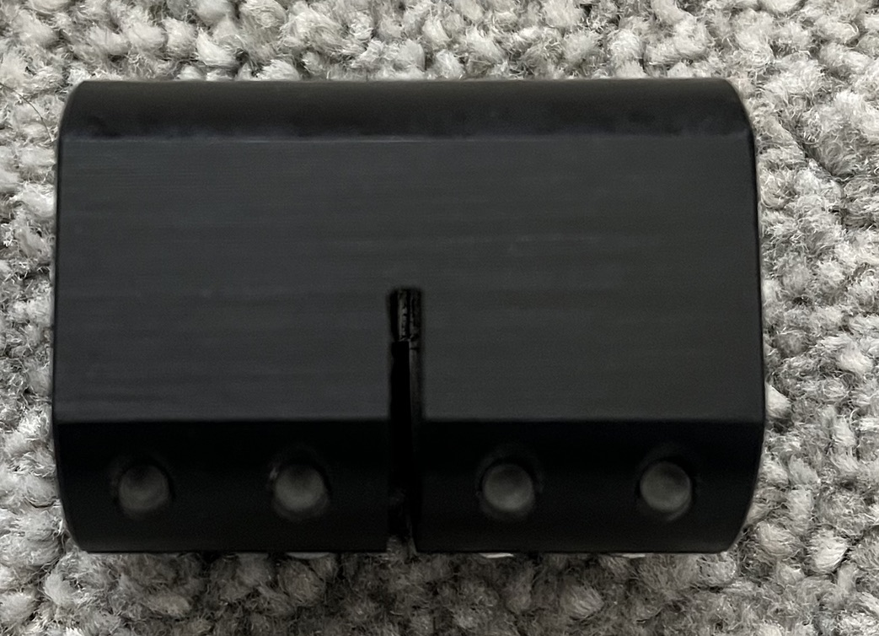 | 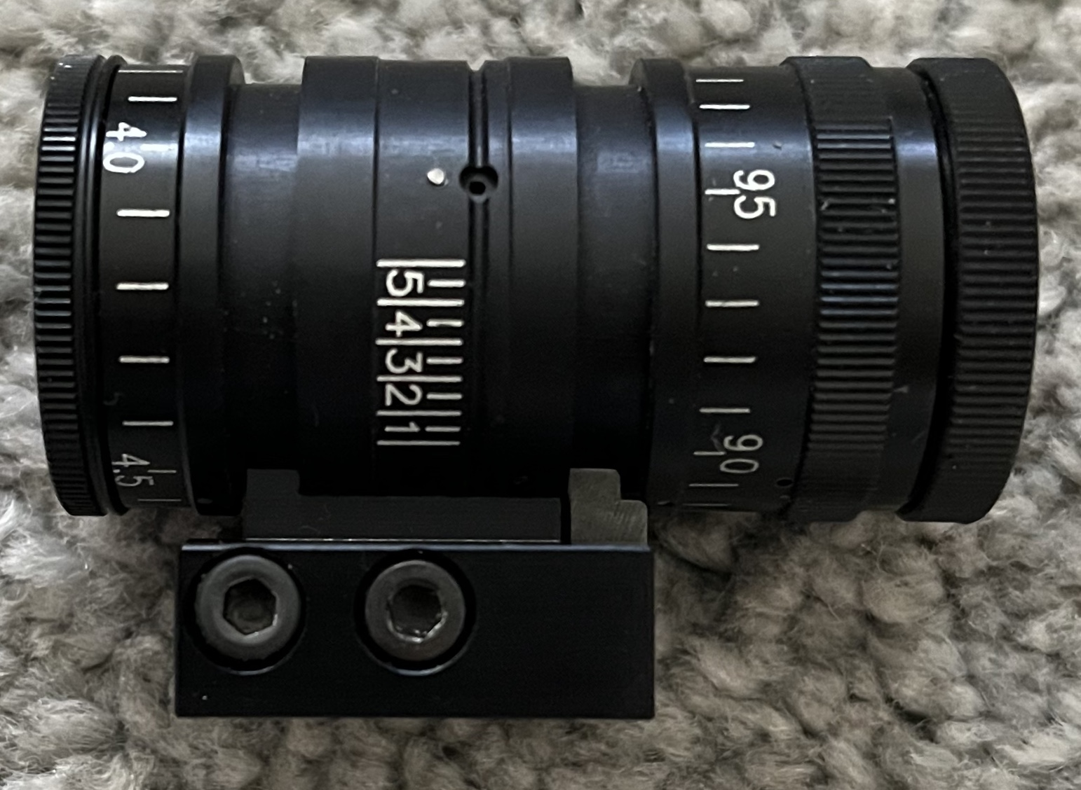
This rifle started life as an 1811 and was re-barrelled in stainless for superb accuracy.
Now sitting in an Anschutz aluminium stock, it has been batch tested and I can include just over 900 rounds within the sale. The sight base can be extended with a 300mm extension tube specifically machined to fit with Centra Duo Vario Foresight (3.8 – 5.8 / 7.6 – 10.2 M22). I will include the standard Anschutz rear sights with an iris, Std foresight and dovetail to fit, Anschutz hand stop, a gun guard carrying case, all the cleaning kit I have (rod, guide, fluid, felt wads, etc) and the original stock.

£1650 ono to a good home! If you’re interested and require other equipment, I have everything and happy to do a deal on mat, scopes, jacket, gloves, glasses etc etc.
For Sale

Please contact trurorifle@gmail.com for further information / purchase.
The rifle and ammunition will require suitable space on a firearms certificate for transfer.

